SUGGESTED TALKING POINTS WHEN ATTENDING THE FAA WORKSHOP MEETINGS APRIL 22-24, 2019 IN PHOENIX AND LAVEEN SCANA website: www.airplanenoise.org

Here are some talking points and action items SCANA suggests you consider when attending the above meetings:

These meetings will be in a format where there will be stations set up that you can visit and talk with representatives; there will be no formal presentations or opportunities to get up and speak to the audience. To see all the materials and information the FAA will present go to their website and scroll down at: https://www.faa.gov/nextgen/nextgen_near_you/community_involvement/phx/
- The main purpose of the meetings is to finalize the process for the Step One actions that moved the westbound departure tracks back to their original locations. But it is also a forum for the FAA to receive input on other flight path issues i.e.: the eastbound departure issues plaguing us in Scottsdale and the northeast valley.
- Go around and talk with the FAA representatives at the various stations. Particularly find the station displaying the Map 1 below to tell those reps that the three northeast departure tracks displayed on that map are unacceptable. Also search out the FAA management folks that will be in attendance and talk with them.
- Fill in and complete the comment forms that will be provided at the meeting. Be sure to include in your own words the talking points below.
- Primary talking points are:
- The three new NextGen routes departing Sky Harbor to the northeast (ZEPER, QUAKY and MRBIL) have destroyed the quality of life residents purposely acquired and have had for years. They were implemented without public input or notice.
- The concentration of overflights can be so repetitive that at times there is no break from having loud and dangerous flights overhead.
- The three routes have created unacceptable safety issues for residents as any
aviation mishap would cause catastrophic ground casualties in these communities.
Safety would be significantly enhanced if the routes were returned to less
populated terrain.
- The Court ruled the new westbound departures out of Sky Harbor were
implemented illegally and had to be returned to their original locations. The east
bound departures were not included in the lawsuit but were implemented in the
same exact fashion. The FAA should provide the same resolution to deserving
residents on the east side as well.
6. Secondary talking points are:
E. These flight tracks are 2,000 feet lower in altitude than previous tracks. Our nearby
mountains, higher elevations, desert terrain and “quiet oasis” environment amplify
the noise patterns from airliners climbing at full thrust.
- The FAA states it never moves noise from one community to another but that is what it did with the NextGen flight paths. It moved noise from no community to our communities.
- The FAA shortened flight routes and “cut corners” to save the airlines a few seconds and a few gallons of fuel. This was done at the expense of public safety with no benefits passed on to the flying public.

OUR REQUEST: THE FAA RETURNS TO PRE-2014 FLIGHT PATHS AND ALTITUDES OVER THE NORTHEAST VALLEY OR TO OTHER NON-POPULATED TERRAIN.

7. From April 24th to May 23rd go to the FAA website where you can submit online comments. Make the same points and submit comments as often as you can. The FAA web address provided above will have a comment form available then.

8. Lastly, be respectful and passionate in your conversations. Tell your personal stories in your own words of how these flight paths have impacted your life and how it was a mistake to place these three NextGen flight paths over our communities and that they must be relocated.

Tell your friends and neighbors about the workshops. Invite them to join you.

ON THE NEXT PAGE ARE TWO MAPS OF THE THREE FLIGHT TRACKS THAT ARE DESTROYING OUR COMMUNITIES ENVIRONMENT.

TAKE THESE MAPS WITH YOU TO THE FAA MEETINGS AND SHOW THE FAA THERE ARE OTHER SENSIBLE ALTERNATIVES TO ROUTE AIR TRAFFIC THAN TO PLACE IT OVER HEAVILY POPULATED COMMUNITIES AND SCHOOLS IN SCOTTSDALE.

MAP 1: THE LIGHT BLUE AND MAGENTA ROUTES ARE THE NEXTGEN ROUTES BEING USED TODAY. THE THREE POINTED OUT ARE DANGEROUS AND CREATE CONSTANT LOW, NOISEY OVERFLIGHTS OVER SCOTTSDALE. SUGGESTED ALTERNATIVES ARE SHOWN.

MAP 2: THIS MAP ALSO SHOWS THE CURRENT FLIGHT PATHS (BLUE) AND SUGGESTTED ALTERNATIVES (RED/GREEN). THIS MAP SHOWS THE TOPOGRAPHY MORE CLEARLY AND SEVERAL SCOTTSDALE COMMUNITIES TO HELP ORENT WHERE THE CURRENT PATHS AND ALTERNATIVE PATHS ARE LOCATED.

MAP 1:
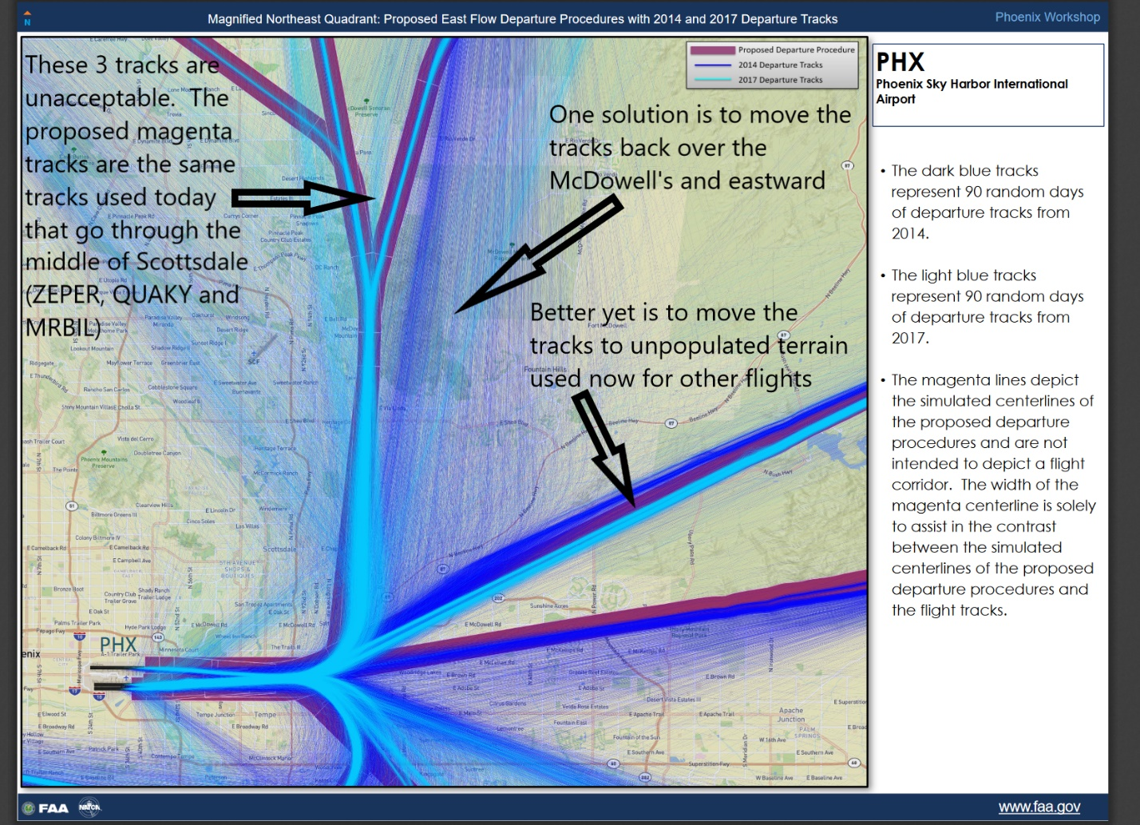

MAP 2:
